**LISA O’NEILL**

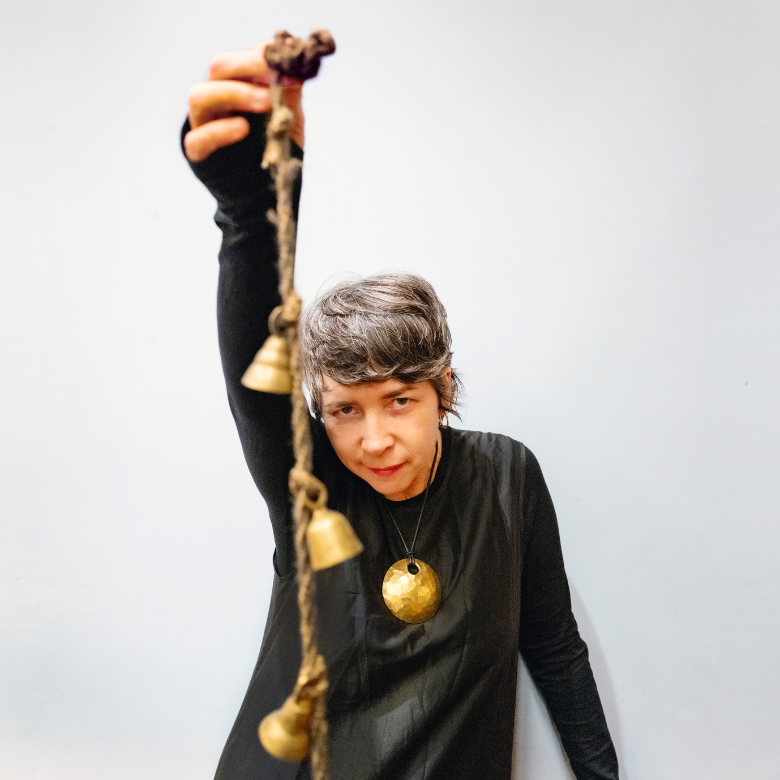

[PHOTO BY JILL FURMANOVSKY](https://jillfurmanovsky.com/)

Following her recent sold out ‘Symphony for the Moons’ shows at Dublin’s National Concert Hall with the National Symphony Orchestra and London’s Barbican with the Britten Sinfonia in December and a 4-night residency in January at The Gate Theatre, Lisa O’Neill announces headline dates across Ireland and the UK, alongside very special guest appearances with The Pogues.

Having recently released a single which features vocals from Libertines, Peter Doherty - ‘Homeless In The Thousands (Dublin in the Digital Age)’ - a song Lisa felt compelled to write in response to the growing issue of homelessness in Dublin. This is not the first time O’Neill has written about social injustices on the cusp of a change. Songs like *Rock the Machine* about unemployment in the Dublin dock lands, *When Cash Was King* about the move to a cashless society and *Violet Gibson* about the Irish woman who attempted to assassinate Mussolini in 1926.

“Giving voice to the disenfranchised is something she does so well, with a particular affinity for women – *“Woman is powerful when not restricted”-* she says…. And she is emblematic of this, with a free singularity that can fold in difficult subjects, such as homelessness…”. **The Irish Times –** live Gate Theatre review

“The Cavan songwriter has grown in stature in recent years as a valued chronicler of the disenfranchised. Songs of social, political and cultural issues preoccupy her as she proves as adept a storyteller as the playwrights long associated with this room.” **The Sunday Business Post -** live Gate Theatre review

Jarvis Cocker has invited Lisa to appear at the Pulp Tramlines Festival on July 25th in Sheffield, she will also be joining The Pogues in the UK as a special guest singer with their Rum, Sodomy & The Lash Tour in May.

Lisa is currently writing new material for her next album.

*

It’s been a remarkable few years for Cavan songwriter. Her acclaimed last album [*All of This Is Chance*](https://lisaoneill.ffm.to/allofthisischance) ranked highly on many critics 2023’s Albums of The Year Lists. Amongst the wealth of praise*,* **Gideon Coe at BBC 6 Music** picked it as his Album Of The Year. It was No. 3 in **Mojo Magazine**’s Folk Albums Of The Year and **Bob Boilen** at **NPR** deemed it his No.3 Album of The Year. It also featured in **Songlines**’, **Uncut Magazine**’s and **The Quietus’s** Albums of the years**.**  May 2023 also saw Lisa make a memorable appearance on [Later with Jools Holland](https://www.youtube.com/watch?v=YV7aWfeZBMA).

A raconteur in the truest sense of the word, O’Neill is a **five-time BBC Folk Award nominee** and her album ***Heard a Long Gone Song*** was named **The Guardian’s 2019 Folk Album of the Year**. She had 2 songs feature in **Peaky Blinders** – Blackbird, her own composition, and an adaptation of Bob Dylan’s ***All the Tired Horses* soundtracked the final scene of the epic TV drama**. Her song ‘**Old Note’** was used in the drama series ‘Say Nothing’.

**Praise for *All of This Is Chance*:**

*“O’Neill is a cultural hero in her own right… a modern artist tapped into the ancient.”* **- New York Times**

*“The first indisputable classic of 2023”* **- Uncut (9/10 Album Review)**

*“Stunning, cinematic”* **- NPR Music**

*“A record that makes a lasting impact… beautiful and evocative”* **- Aquarium Drunkard**

*“Uncompromising, stunning, soul-shaking stuff.”* **-The Guardian**

*“A beautiful and bold album”* **– PopMatters**

*“In a word. Mesmeric”* ***-* Songlines (5/5 Lead ‘Top Of The World’ Review)**

*“You’ll be lucky to hear a better record all year”* ***–* TheSunday Times, Culture (5/5 Album Review)**

*“Quite simply a modern masterpiece”* **– The****Morning Star (5/5 Album Review)**

*“There’ll scarcely be a better record released this year than All Of This Is Chance.”* **– Hot Press (9/10 Album Review)**

*‘'All Of This Is Chance' is an epic canyon of sense and sound... a timeless piece of work, wholly unbound by style or genre, a universal shot of medicinal magic.’’* ***-* Folk Radio (Album Of The Month)**

*“You’re unlikely to hear a more original, more powerful, more breathtaking release than this all year”* ***-* Narc Magazine (5/5 Album Review)**

*“A strikingly individual album, a cohesive whole musically and lyrically and unlike anything you’ll hear elsewhere.”* **- The Arts Desk (4/5 Album Review)**

**Mojo (4/5 Album Review) / The Guardian (4/5 Album Review) / The Irish Times (4/5 Album Review) / The Yorkshire Post (Album of The Year)**

Watch The Video For *Old Note* [Here](https://www.youtube.com/watch?v=wQGUYgNhQa4&feature=youtu.be&themeRefresh=1) / Watch The Video For *Silver Seed* [Here](https://www.youtube.com/watch?v=7VIaU7nC1mk)

[Website](https://lisaoneill.ie/home/) / [Bandcamp](https://lisa-oneill.bandcamp.com/) / [Instagram](https://www.instagram.com/lisaoneillmusic/)