**FOR IMMEDIATE RELEASE**

JUNE 11, 2024

**DELICATE STEVE ANNOUNCES**

***DELICATE STEVE SINGS***

**SHARES “I’LL BE THERE”**

**WATCH DELICATE STEVE’S “I’LL BE THERE” VIDEO**

**ANNOUNCES US TOUR**

**NEW LP OUT**

**AUGUST 16TH ON ANTI-**

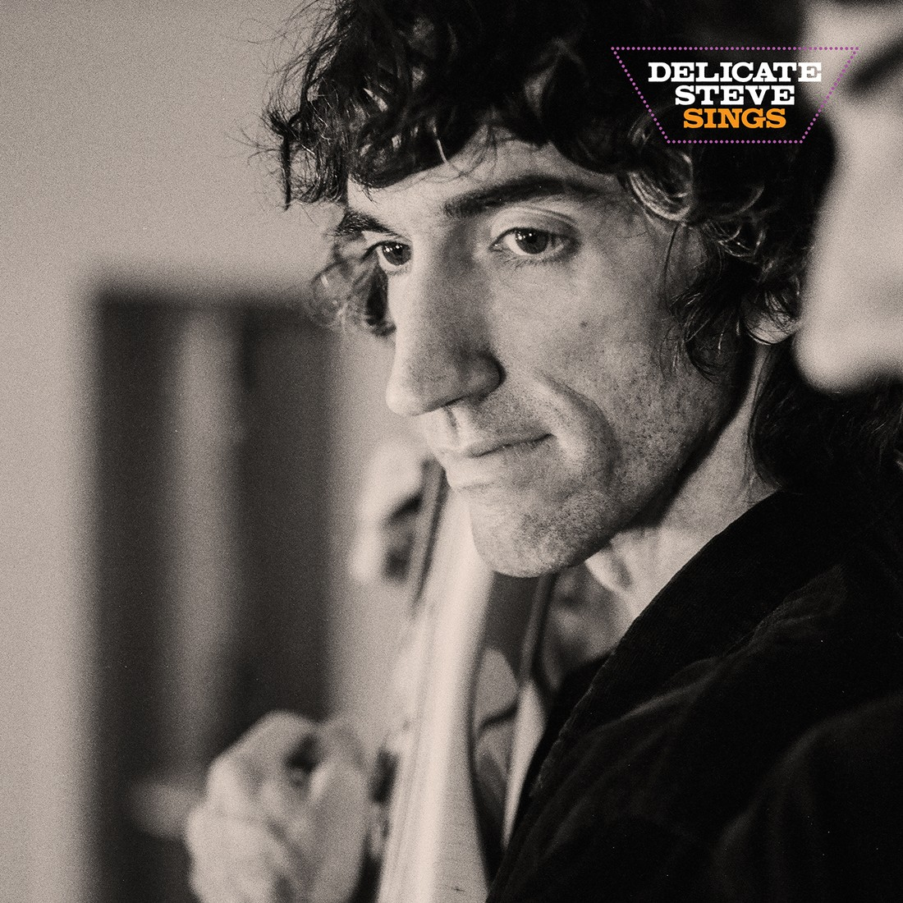

*"Steve Marion has become something you didn’t know you even needed in this day and age: a guitar hero...his luminous leads form the emotional undercurrent around which everything else flows.”* – ***Pitchfork***

*"Delicate Steve slyly eludes generalizations...there’s no telling when a*

*track will take an abrupt, peculiar tangent."*

***New York Times***

*"Delicate Steve's music maintains the capacity to surprise...[his music] is*

*bursting with eccentric ideas and curlicues that playfully threaten to*

*unmoor any given song altogether."*

***NPR***

*"There are few electric guitar masterminds putting their expertise to such*

*unique ends as Steve Marion."*

***Consequence***

Today Steve Marion, the critically acclaimed – and completely wordless – songwriter and guitarist known as **Delicate Steve**, is announcing a new album called ***Delicate Steve Sings*** (out **August 16th** on **ANTI-**). Is the album title a reference to the instantly recognizable “voice” of his guitar? Does he actually sing this time? Has he not been singing all along? That’s the crux of *Sings* — Marion is the rare guitarist where you can put on any of his records and know exactly who’s playing. In an indie rock landscape stuffed end-to-end with guitars and amplifiers, nobody else sounds like this.

That unique voice has kept Steve busy in an unpredictable variety of settings. The sheer spread of his work outside his own records — collaborating with Miley Cyrus and Paul Simon, playing in Amen Dunes and the Black Keys, and being sampled by Kanye — doesn’t mean Steve’s a chameleon. It means he’s singular.

One night while on a trip to Greece, Marion looked out over the sea while listening to Willie Nelson’s pop standards record *Stardust*, a cosmic epiphany washing over him about what his next record could be. *Delicate Steve Sings* is a record centered on channeling iconic voices with his guitar. In doing so, Marion is casting himself in the role of iconic singers like Willie who make standards their own. In the process, he reveals just how singular (dare we say iconic) that voice is. The guitar sings these songs — smoothly, sweetly, boldly, and on its own terms.

*Delicate Steve Sings*, was recorded with **Jonathan Rado** on bass, **Kosta Galanopolous** on drums, **Renata Zeiguer** providing strings, and co-writer **Elliot Bergman**. You can hear this team of exceptional musicians approach the album with the same smooth reverence you’d hear on something like Willie Nelson's classic. Still, there’s a requisite subversiveness to what Marion’s doing here — though there are some covers, this isn’t a full-on standards album.

Today, Steve is sharing a first taste of the LP, an original song with a title that suggests it might be new recordings of classic. That single is called "**I'll Be There**," and it is accompanied by a video directed by **Joe Cappa**.

**WATCH DELICATE STEVE’S “I’LL BE THERE” VIDEO**

“I’ll Be There” was inspired by the singing style of "Lean On Me" and "Ain't No Sunshine" singer Bill Withers. Marion's collaborators build an arrangement full of subtle supporting flourishes, with Zeiguer's strings adding an understated grandeur to a track that brilliantly captures the emotive capacity of Marion's guitar playing.

Says Marion of the single:

“‘*I'll Be There’ is a song inspired by Bill Withers. His music is so sincere it’s almost impossible to believe it when you first hear it. I came up with what the guitar is playing while thinking of his song ‘Lean on Me’. Once I felt embarrassed enough about what I was playing, I knew that's what it had to be.”*

Joe Cappa adds of the video:

*"To me the song evokes endless love, and since I recently acquired some super 8 film I thought ‘why not make a trendy wedding video with it?’ Steve and I gathered up some friends, headed to Palm Springs and shot the music video over the weekend. Everyone was a trooper on set- enduring a super cold and windy shoot in Joshua tree and lugging around awkwardly crafted puppet women."*

In support of the album Delicate Steve will be embarking on a US tour. Full details of that run can be found below.

[**PREORDER / PRE SAVE DELICATE STEVE SINGS**](https://delicatesteve.ffm.to/sings)

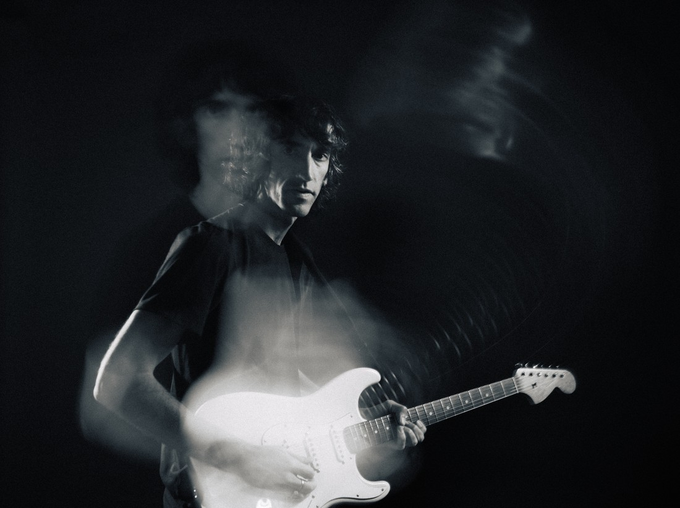

Credit: Eleanor Petry

**Tour Dates**

10/2/24 – Boston – Middle East

10/3/24 – Boston – Middle East

10/4/24 – Burlington – Nectars

10/5/24 – Burlington – Nectars

10/8/24 – NYC – Sultan

10/9/24 – NYC – Sultan

10/10/24 – Philly – PhilaMOCA

10/11/24 – Philly – PhilaMOCA

10/12/24 – DC – Songbyrd

10/17/24 – Pittsburgh – Bottlerocket

10/18/24 – Toronto – Monarch

10/19/24 – Toronto – Monarch

10/21/24 – Chicago – Schubas

10/22/24 – Chicago – Schubas

10/23/24 – Milwaukee – Vivarium

10/25/24 – Madison – UW

10/26/24 – Minneapolis – 7th St

**Tracklist**

1. Cherry
2. Baby
3. I’ll Be There
4. Easy For You
5. Yesterday
6. Medieval Eyes
7. Wind Won’t Blow
8. Stay With Me
9. Walkin’
10. These Arms of Mine

**Delicate Steve Socials**

[Twitter](https://x.com/delicatesteve) | [Instagram](https://www.instagram.com/delicatesteve) | [Bandcamp](https://delicatesteve.bandcamp.com/) | [Facebook](https://www.facebook.com/DelicateSteve/) | [YouTube](https://www.youtube.com/user/delicatesteve) | [Website](https://delicatesteve.com/)